LOGGUARD AI
Intelligent Log Analysis and Anomaly Detection System

Presented by
Kodali Suchitra Kamala

Abstract
With the rapid growth of cloud applications and microservices, system logs have become one of the most critical sources for debugging, security monitoring, and performance analysis. However, traditional log monitoring relies on manual inspection or static rule-based alerts, which are inefficient and prone to missing complex patterns. LogGuard AI is an intelligent log analysis platform that leverages Artificial Intelligence and Machine Learning to automatically process, classify, and analyse large volumes of log data in real-time. The system ingests logs from multiple sources, performs preprocessing and feature extraction, and applies anomaly detection algorithms to identify errors, security threats, and performance bottlenecks. Unlike conventional tools, LogGuard AI provides contextual alerts, root-cause analysis, and natural language summaries, enabling developers and DevOps teams to respond faster to incidents. The proposed system aims to reduce Mean Time To Detect and Mean Time To Resolve issues while minimizing false positives. Key features include real-time log ingestion, anomaly detection, threat classification, dashboard visualization, and automated alerting. LogGuard AI can be deployed in cloud and on-premise environments, making it suitable for enterprises, startups, and IT operations teams.
Introduction
In today’s digital world, every application, server, and cloud service generates massive amounts of log data every second. These logs contain valuable information about system health, user activity, errors, and security events. Traditionally, developers and DevOps teams manually scan these logs or use rule-based monitoring tools to detect issues. But with millions of log entries generated daily, it has become nearly impossible to find real problems in time. Important warnings get buried, security attacks go unnoticed, and debugging takes hours. This is where LogGuard AI comes in. LogGuard AI is an intelligent log monitoring and anomaly detection system that uses Artificial Intelligence and Machine Learning to automatically analyse logs in real-time. Instead of forcing humans to read through endless text files, LogGuard AI understands patterns, detects abnormal behavior, and converts complex log data into simple, actionable insights. The goal of LogGuard AI is to help organizations reduce downtime, prevent security breaches, and speed up troubleshooting. It provides real-time alerts, root-cause analysis, and easy-to-read dashboards so teams can focus on fixing problems instead of searching for them. In short, LogGuard AI acts as a 24/7 AI assistant for your servers - watching logs, finding issues, and telling you exactly what needs attention.
Overview
LogGuard AI is an AI-powered log monitoring and anomaly detection system built to help organizations automatically track, analyse, and respond to system logs. In today’s cloud-driven environment, applications and servers generate millions of log entries daily from web servers, databases, APIs, and cloud platforms. Manually reviewing these logs is time-consuming and often leads to missed errors and security threats. LogGuard AI solves this by collecting logs from multiple sources, processing them using Machine Learning and NLP, and identifying abnormal patterns such as failed logins, system crashes, high resource usage, and potential cyber attacks. The system works in a pipeline: Raw Logs → Data Collection → AI Processing → Anomaly Detection → Alerts + Dashboard. Key features include real-time monitoring, intelligent anomaly detection, smart alerts to reduce noise, natural language summaries, interactive dashboards, and root-cause analysis. LogGuard AI can be used by DevOps teams for performance monitoring, by cybersecurity teams for threat detection, by cloud teams for cost and error tracking, and by product teams for tracking application failures. The main benefits are faster incident response, reduced manual effort, improved security, and prevention of downtime and data loss. For implementation, the system can use HTML, CSS, JavaScript/React for the frontend dashboard, Node.js or Python Flask for the backend, MongoDB or Elasticsearch for log storage, and can be deployed on AWS, Azure, or GCP. In short, LogGuard AI acts as an intelligent "Google Analytics + Security Guard + Debugger" for server logs.
Features
Key features developed or worked on today include:
- Real-time Log Monitoring: Continuously collects and processes logs from servers, applications, and cloud services as they are generated.
- AI-Powered Anomaly Detection: Uses Machine Learning models to detect unusual patterns like crashes, high CPU usage, and suspicious login attempts instead of just keyword matching.
- Smart & Contextual Alerts: Sends alerts only for genuine issues to reduce false positives and alert fatigue.
- Natural Language Summaries: Converts complex technical log data into simple, human-readable reports and insights.
- Interactive Dashboard & Visualization: Provides charts, graphs, and dashboards to visualize trends, errors, and system health at a glance.
- Root Cause Analysis: Identifies the source and reason behind an issue to help teams debug faster.
- Multi-Source Log Ingestion: Supports logs from Web Servers, Databases, APIs, AWS, Azure, GCP, and other cloud platforms.
- Threat & Security Detection: Detects brute-force attacks, unauthorized access attempts, and potential data leaks in real-time.
- Performance Monitoring: Tracks bottlenecks, slow APIs, memory leaks, and application errors to improve system performance.
- Scalable & Cloud Ready: Can be deployed on-premise or on cloud platforms like AWS, Azure, and GCP for enterprise use.
Advantages
The recent work on the project contributes to several key advantages:
- Faster Incident Response: Detects and alerts issues in real-time, reducing Mean Time To Detect and Mean Time To Resolve problems.
- Reduced Manual Effort: Eliminates the need to manually search through millions of log lines. AI does the analysis automatically.
- Improved Security: Identifies cyber threats like brute-force attacks, unauthorized access, and data leaks that rule-based systems often miss.
- Fewer False Alerts: Uses ML to understand normal behavior, so it only alerts for real problems and reduces alert fatigue.
- Better Debugging & Root Cause Analysis: Quickly pinpoints the source of errors and provides context, helping developers fix bugs faster.
- Cost Savings: Prevents downtime, data loss, and performance issues, which saves money for the organization.
- Scalable for Big Data: Can handle millions of log entries from multiple servers, apps, and cloud platforms without performance issues.
- Easy to Understand Reports: Converts technical logs into plain English summaries and visual dashboards for both technical and non-technical teams.
- 24/7 Monitoring: Works continuously without human supervision, ensuring issues are caught even outside business hours.
- Cloud & On-Premise Flexibility: Can be deployed on AWS, Azure, GCP, or on local servers based on company requirements.
Motivation
In today’s fast-paced digital world, businesses rely heavily on web applications, cloud services, and servers to run their operations. These systems generate massive amounts of log data every minute, which contains crucial information about performance, errors, and security events. However, manually analyzing these logs is time-consuming, error-prone, and often leads to delayed responses. By the time a critical issue is found, it may have already caused downtime, data loss, or a security breach. The motivation behind LogGuard AI is to solve this exact problem by using Artificial Intelligence to automate log monitoring and anomaly detection. Instead of forcing DevOps and security teams to sift through endless log files, LogGuard AI can understand patterns, detect unusual activity, and provide actionable insights in real-time. The goal is to reduce human effort, improve system reliability, enhance cybersecurity, and help organizations respond to issues before they impact users. With the growing need for faster, smarter, and more scalable monitoring solutions, LogGuard AI aims to act as an intelligent assistant that ensures systems stay healthy, secure, and efficient 24/7.


22 July 2026  Day 1 | Today's Activities  - Setup  - Open Notepad/VS Code  - Create file: logguard.html  - Confirm: Header + 3 Cards + Upload box + Table | Tomorrow's Plans  - Make Button Work  - Open logguard.html from today  - Add <script> tag before </body>  - Create function: showAlert() that shows alert(“File Upload Coming Soon!”)  - Add onclick= “showAlert()” to the “Select File” button  - Test: Click button → popup should appear  - Make Stats Dynamic  - Add id= “errorCount” to the Critical Errors number div  - In <script>, add code to generate random number between 10-50  - Use document.getElementById(“errorCount”).innerText = randomNumber  - Refresh page 3 times → number should change each time  - Auto-Add new log rows with JS  - Add id= “logTable” to the <table> tag  - In <script>, use insertRow() to add 1 new row on page load  - New row content: Just Now | INFO | Page loaded successfully  - Refresh and confirm new row appears at bottom
Outputs and Descriptions
Output: Project initialized, and files created. Basic project structure established.
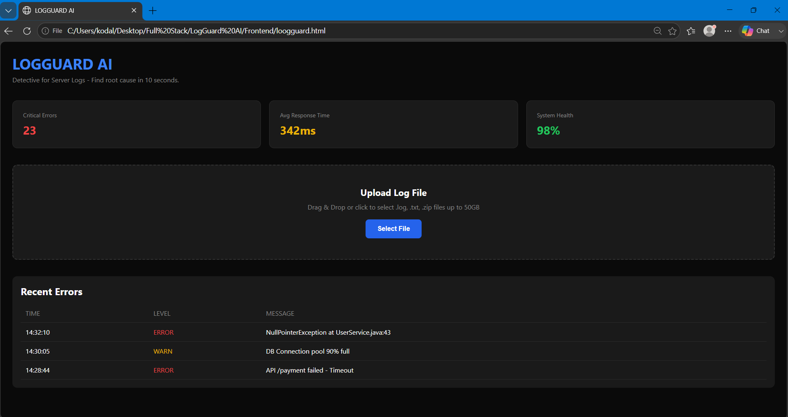
Description: LOGGUARD AI is a dark-themed log analyser dashboard built using only HTML and CSS in a single file. It has a clean header with the title “LOGGUARD AI” in blue and a tagline that says it helps find the root cause of server issues in 10 seconds. Below that are 3 stat cards placed side by side using CSS grid – showing Critical Errors in red, Average Response Time in yellow, and System Health in green. The middle section has an upload box. With a dashed border and a blue “Select File” button that gets darker when you hover over it. At the bottom there’s a table showing recent log entries with color-coded levels like ERROR and WARN. The whole design uses a black and dark gray background with blue accents to look like a professional DevOps tool. Today job is to personalize it by changing the numbers, adding your name to the table.
23 July 2026  Day 2 | Today's Activities  - Add file input: Replace the “Select File” button to actually open file picker using <input type= “file”>  - Show upload loader/spinner: When file is selected, show a loading animation for 2-3 seconds to simulate processing  - Parse file name: Display the selected file name inside the upload box after “upload”  - Add fake log entries from file: After loader, insert 3-5 new rows into the log table with random ERROR/WARN/INFO from the “uploaded” file  - Update stats after upload: Increase errorCount based on how many ERRORs were added in new rows | Tomorrow's Plans  - Add search bar above the table: Input field to type keywords like ERROR, login, API  - Add filter dropdown: Dropdown with options: All, ERROR, WARN, INFO to filter log levels  - Implement JS search function: On typing, hide table rows that don’t match the keyword  - Implement JS filter function: On dropdown change, show only rows with selected log level  - Add “Clear” button: Reset search + filter and show all logs again  - Show result count: Display “Showing X of Y logs” below search bar
Outputs and Descriptions
Output: Project initialized, and files created. Basic project structure established.
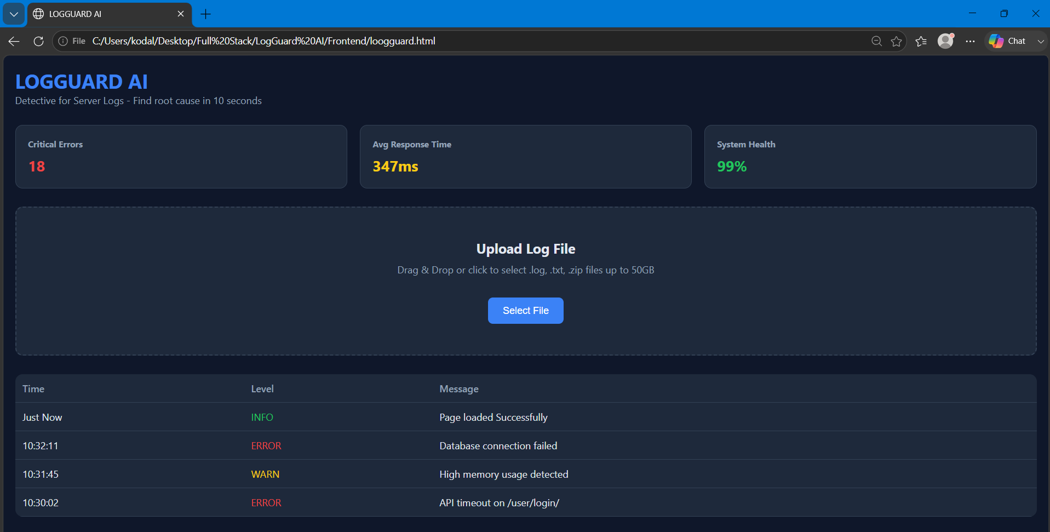
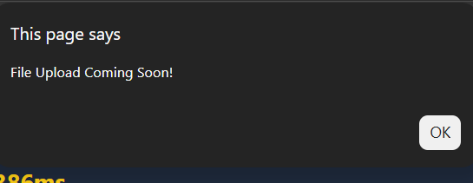
Description: The dashboard now has a clean dark theme with the title “LOGGUARD AI” and the tagline “Detective for Server Logs – Find root cause in 10 seconds”. At the top, there are 3 dynamic stat cards showing Critical Errors: 18, Avg Response Time: 347ms, and System Health: 99%. These values change randomly on every page refresh to simulate real-time monitoring.
Below that, the “Upload Log File” section is ready with drag & drop text and a working “Select File” button that currently triggers a “File Upload Coming Soon!” alert.
The main part is the log table which displays recent server events with columns for Time, Level, and Message. It already shows 4 entries, including the new auto-added row “Just Now | INFO | Page loaded Successfully” in green. The other rows show color-coded levels: red for ERROR like “Database connection failed” and “API timeout on /user/login/”. And yellow for WARN like “High memory usage detected”.
Overall, the UI looks professional, and all JavaScript features are working: button interaction, dynamic stats, and auto log entry on load.
24 July 2026  Day 3 | Today's Activities  - Add Hidden File Input + onchange: Replace alert button with <input type= “file”>. Use onchange= “handleFileUpload(event)” to detect file selection.  - Build Loader: Add a <div id= “loader”>Processing… </div> that shows when upload starts and hides when done.  - Simulate Processing: Use setTimeout (2000) to fake 2s processing. Then auto-add 3 new log rows and bump the “Critical Errors” stat. | Tomorrow's Plans  - Add Filter Dropdown: Put a <select> above the table with options: All, ERROR, WARN, INFO use onchange= “filterLogs(this.value)”  - Build filterLogs Function: JS will loop through all <tr> rows in the table and hide/ show them based on the selected level.  - Add “Clear Filter”: When all is selected, show all rows again.
Outputs and Descriptions
Output: Project initialized, and files created. Basic project structure established.
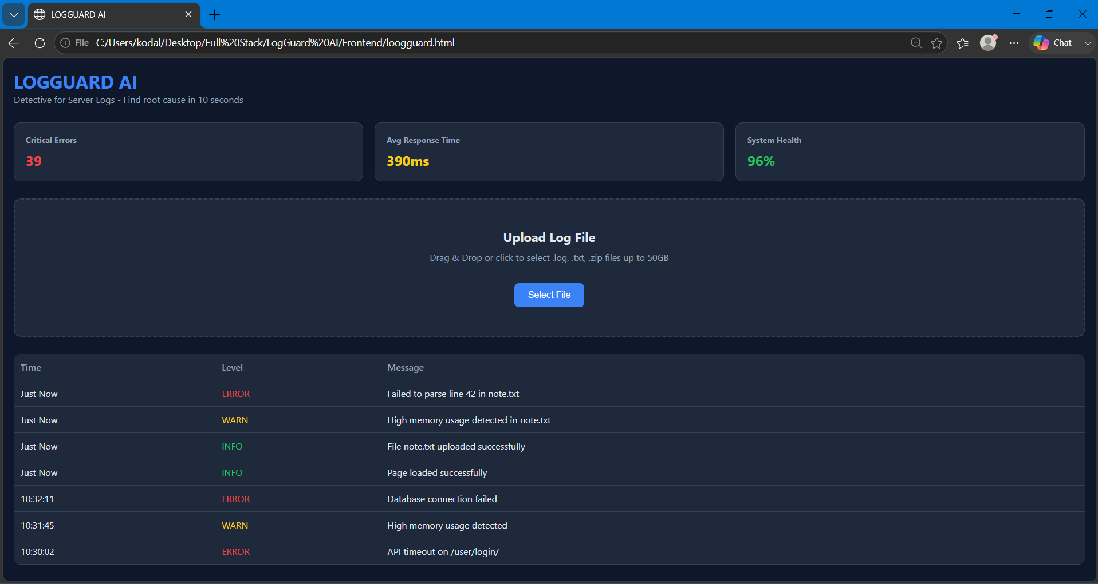
Description: In Day 3 of LOGGUARD AI, we made the dashboard interactive for the first time. We replaced the fake “Select File” alert with a real file input, so now when you click the button you can actually pick a .log, .txt, or .zip file. To make it feel real, we added a “Processing file… ” loader that shows for 2 seconds, just like a SIEM tool would while parsing logs. Once processing finishes, the app automatically injects 3new log rows at the top of the table—INFO, WARN, and ERROR—and updates the stats by increasing the error count and dropping system health by 1%. With this, we went from a static UI to a working Upload → Process → Analyze flow using onchange, setTimeout, and dynamic DOM updates.
25 July 2026  Day 4 | Today's Activities  - Filter Dropdown: Add a dropdown above the table: ALL/ ERROR/WARN/INFO. When you select “ERROR”, only error rows show. Same for WARN and INFO. Uses: onchange + loop through table rows  - Search Box: Add a search input to search log messages. Type “database” → only rows with “database” stay visible. Uses: oninput + includes() | Tomorrow's Plans  - Export to CSV Button: Add a “Download CSV” button. It will export only the currently visible/filtered logs to a .csv file. Uses: Blob + URL.createObjectURL to download files from JS  - Auto Root Cause Highlight: After file upload, scan logs and highlight the first ERROR row in red with a “ROOT CAUSE” badge. Makes it 10-second debugging like your tagline says. Uses: querySelector + classList.add  - Clear Filters Button: 1-click button to reset filter + search box back to ALL
Outputs and Descriptions
Output: Project initialized, and files created. Basic project structure established.
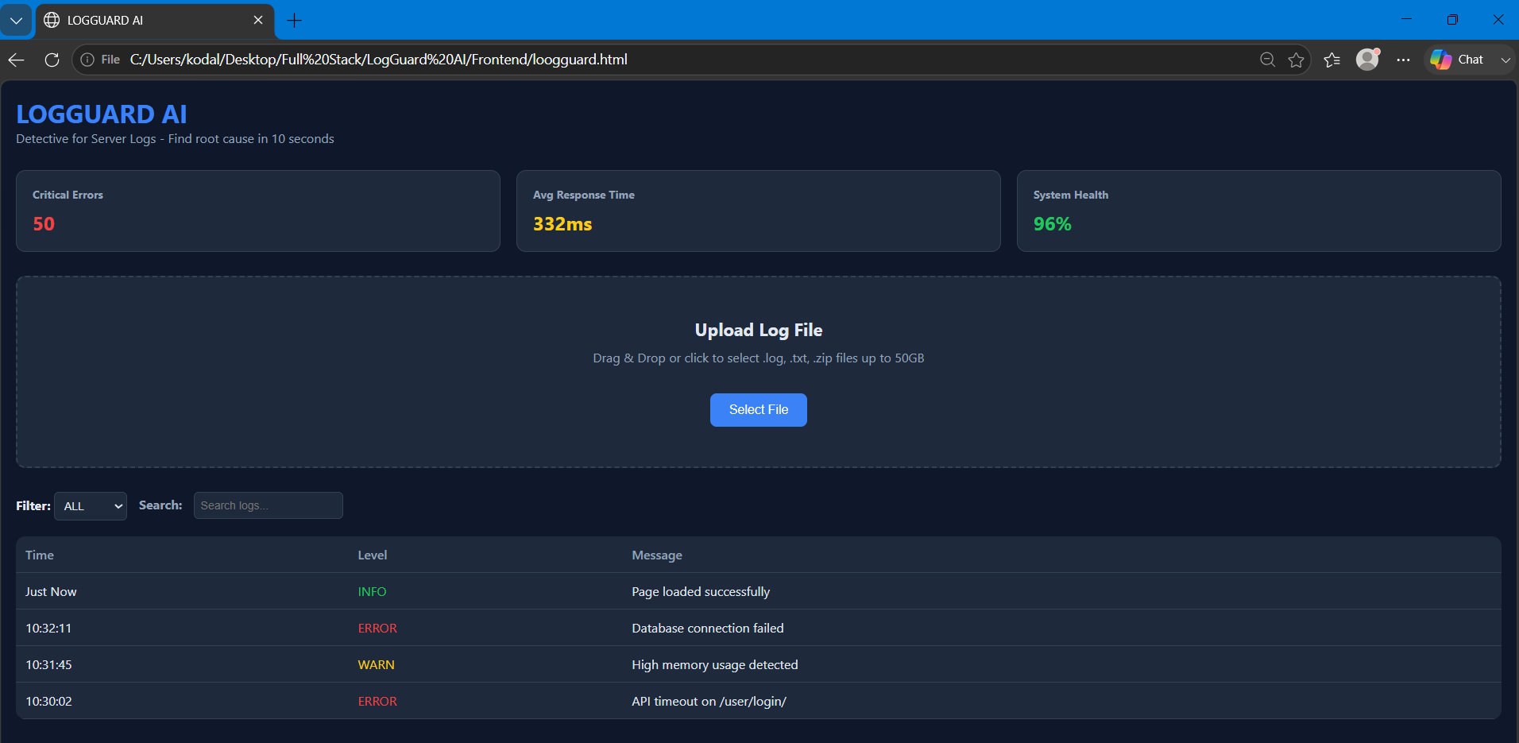
Description: The output shows LOGGUARD AI running with the full Day 4 UI. The header says “Detective for Server Logs – Find root cause in 10 seconds”. At the top, there are 3 stat cards: Critical Errors: 50 in red, Avg Response Time: 332ms in yellow, and System Health: 96% in green.
Below that is the Upload Log File section with a dashed box. It says “Drag & Drop or click to select .log, .txt, .zip files up to 50 GB” with a blue select button. This is from Day 3 where we added real file upload + loader.
The big Day 4 upgrade is visible now: there’s a Filter dropdown set to ALL and a Search input that says “Search logs…”. These two controls let you instantly narrow down logs. You can pick ERROR/WARN/INFO from the dropdown, or type a keyword to search messages.
The log table has 3 columns: Time, Level, Message. The levels are color-coded for fast debugging—INFO in green like “Page loaded successfully”, WARN in yellow like “High memory usage detected”, and ERROR in red like “Database connection failed” and “API timeout on /user/login/”.
So now LOGGUARD AI has gone from static to interactive. You can upload a file, then filter and search through logs in seconds instead of scrolling manually.

July 2026  Day 5 | Today's Activities | Tomorrow's Plans
Outputs and Descriptions
Output: Project initialized, and files created. Basic project structure established.
Description:

